Logo update:

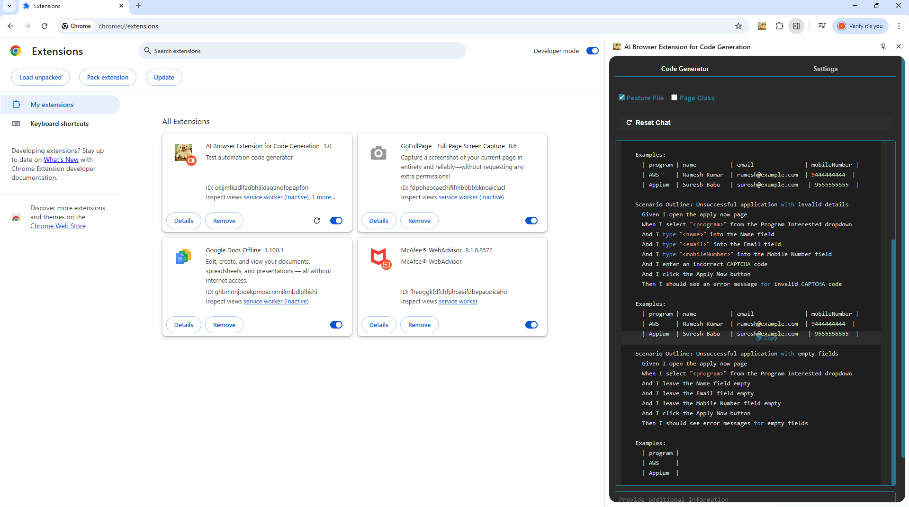

To change the logo- modified the image name in the manifest.js and config--->app.config.js based on the logos available in the asset\images

Removed the extension:

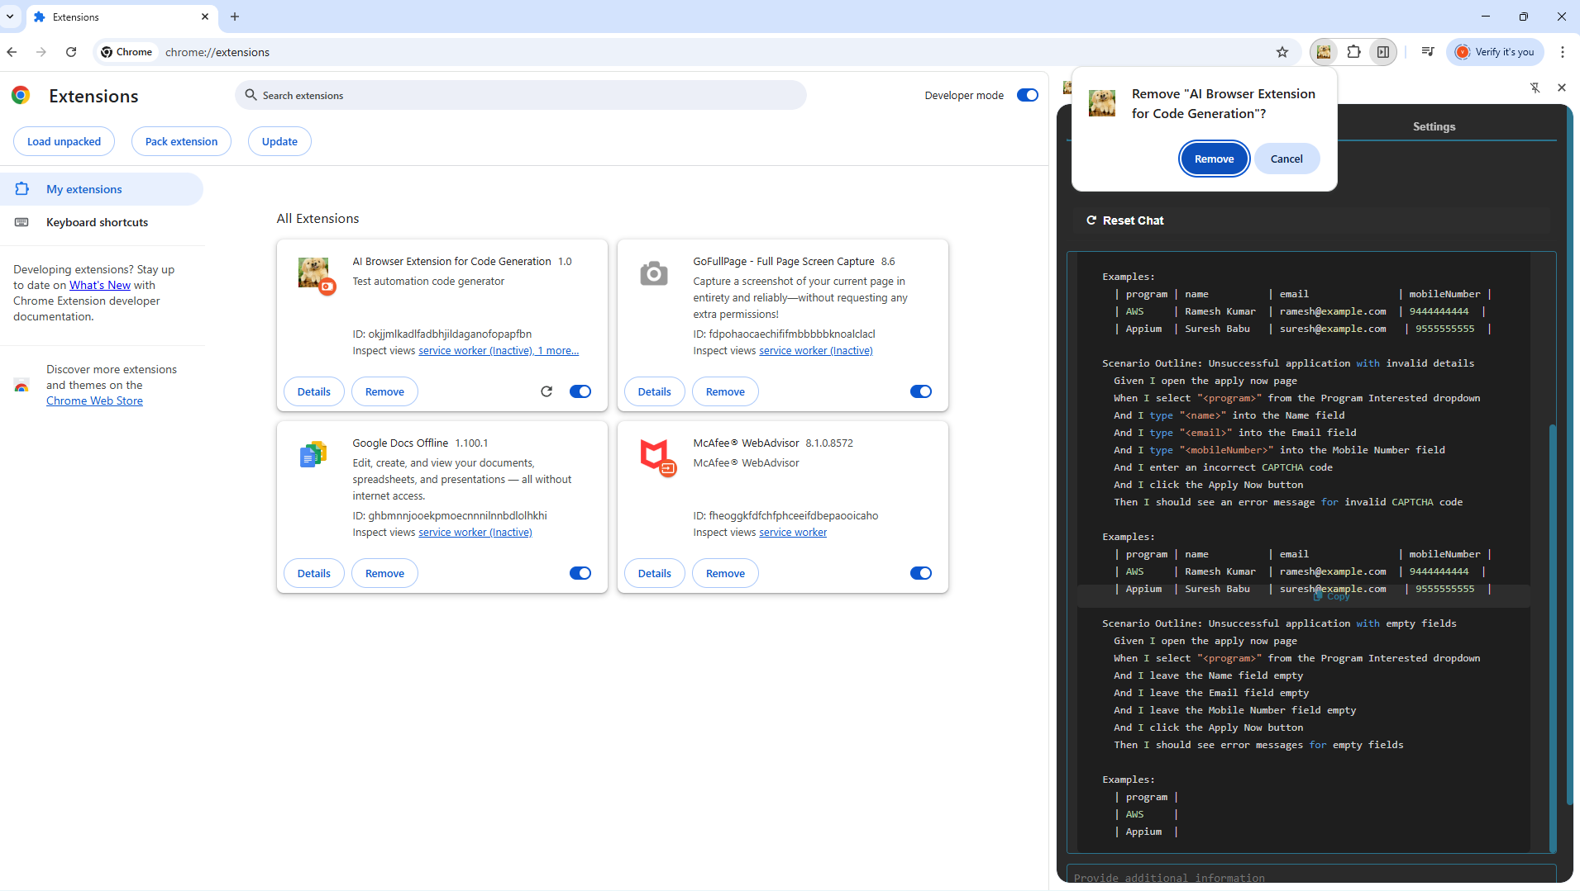

Go to the chrome extension:
chrome://extensions/
Click on Load unpacked on the left side
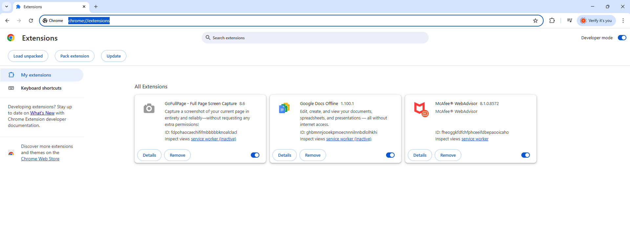

Qeagle logo

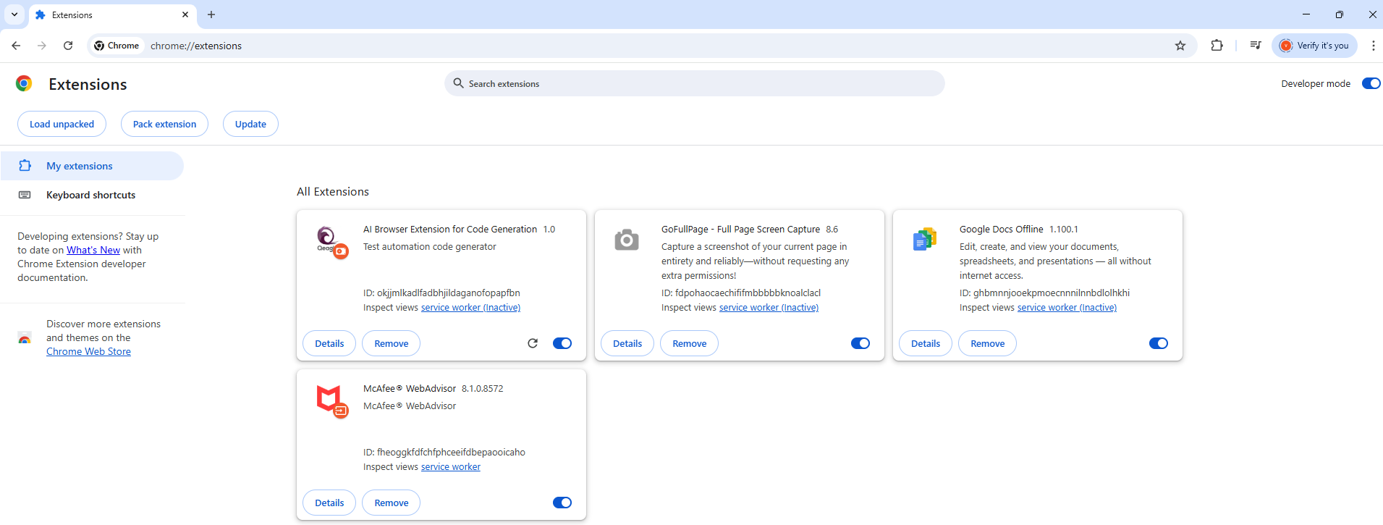

Bug Magnet Vs Fake Filler chrome extension Assignment:

Bug Magnent-Helps more in the Validation of each fields,negative cases for each field with null value and more of validation of fields

Whereas FakeFiller-Helps to fill in values:

- For each input

- Also option to Fill the inputs and

- Fill the form

Fill inputs helps to enter the values in the Text field alone whereas it will not tick the checkbox

Fill forms will help to fill the data and all the details like ticking the checkbox

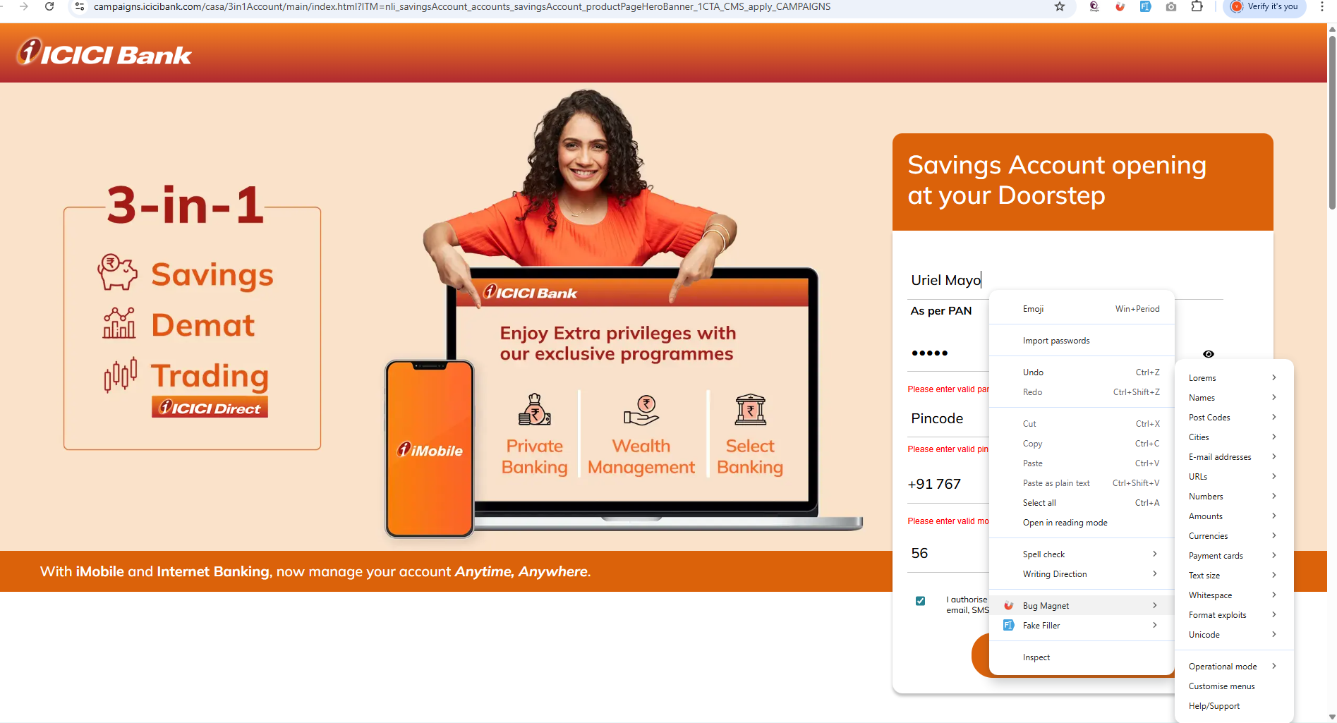



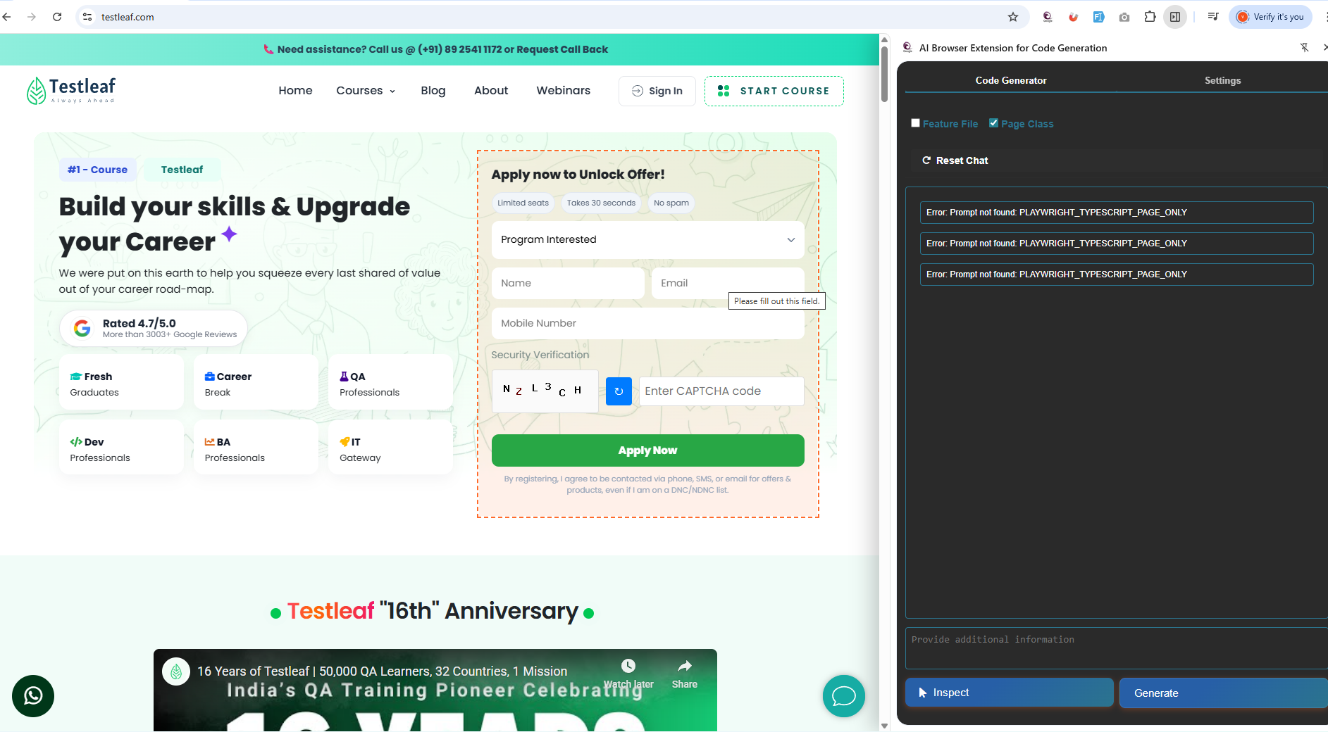

Grammarly:

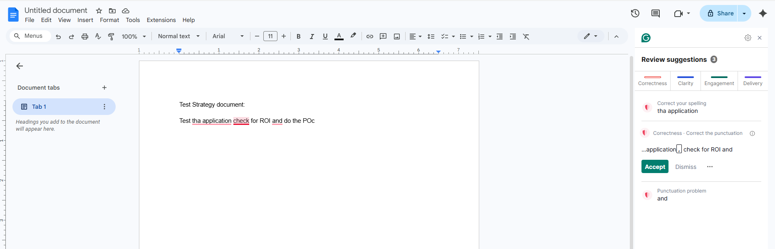

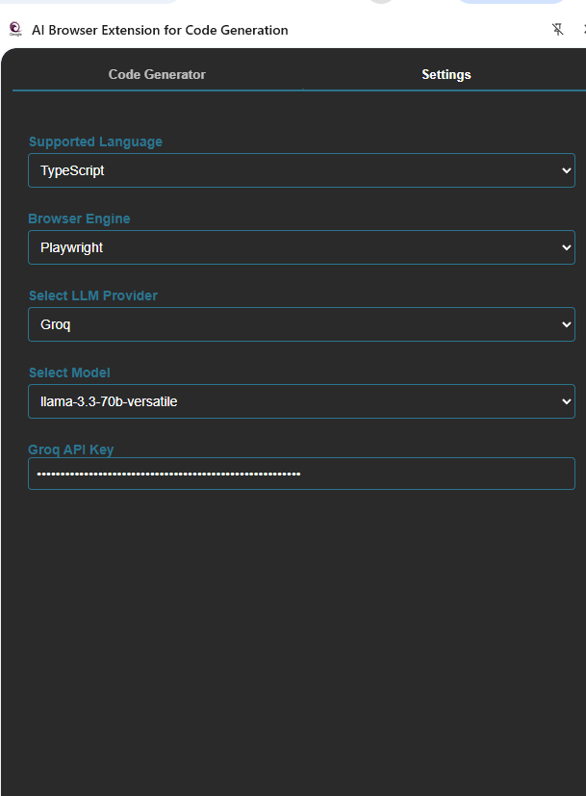

import { Page, Locator } from '@playwright/test';

/**
* Page Object for TestLeaf Apply Now Page
*/
export class ApplyNowPage {
readonly page: Page;
readonly programInterestedDropdown: Locator;
readonly nameField: Locator;
readonly emailField: Locator;
readonly mobileNumberField: Locator;
readonly captchaField: Locator;
readonly applyNowButton: Locator;
readonly captchaImage: Locator;
readonly refreshCaptchaButton: Locator;

constructor(page: Page) {
this.page = page;
this.programInterestedDropdown = page.locator('select[id="Dropdown"]');
this.nameField = page.locator('input[id="name"]');
this.emailField = page.locator('input[id="email"]');
this.mobileNumberField = page.locator('input[id="PhoneNumber_countrycode"]');
this.captchaField = page.locator('input[id="captcha"]');
this.applyNowButton = page.locator('button:has-text("Apply Now")');
this.captchaImage = page.locator('img[id="captcha-img"]');
this.refreshCaptchaButton = page.locator('button[type="button"]:has-text("↻")');
}

/**
* Navigate to the TestLeaf Apply Now Page
*/
async goto(): Promise<void> {
await this.page.goto('https://www.testleaf.com/');
}

/**
* Select a program from the dropdown
* @param program - The program to select
*/
async selectProgram(program: string): Promise<void> {
await this.programInterestedDropdown.selectOption({ value: program });
}

/**
* Fill in the name field
* @param name - The name to fill in
*/
async fillName(name: string): Promise<void> {
await this.nameField.fill(name);
}

/**
* Fill in the email field
* @param email - The email to fill in
*/
async fillEmail(email: string): Promise<void> {
await this.emailField.fill(email);
}

/**
* Fill in the mobile number field
* @param mobileNumber - The mobile number to fill in
*/
async fillMobileNumber(mobileNumber: string): Promise<void> {
await this.mobileNumberField.fill(mobileNumber);
}

/**
* Fill in the captcha field
* @param captcha - The captcha to fill in
*/
async fillCaptcha(captcha: string): Promise<void> {
await this.captchaField.fill(captcha);
}

/**
* Click the apply now button
*/
async clickApplyNow(): Promise<void> {
await this.applyNowButton.click();
}

/**
* Refresh the captcha
*/
async refreshCaptcha(): Promise<void> {
await this.refreshCaptchaButton.click();
}
}

Python +Selenium

